Stephen Smith
CMSI 282
Dr. Dorin
2/4/2014
Fibonacci Function Evaluation

Problem Statement:
Compare the runtimes of recursive and iterative functions that generate the nth Fibonacci number.

Code:
import java.math.BigInteger;

public class fib {
public static void main (String[]args) {

int[] fibNumbers = {1, 5, 10, 15, 20, 25, 30, 35, 40};

for (int j = 0; j < fibNumbers.length; j++) {

long totalTime = 0;
for (int i = 1; i <= 1000; i++) {
long startTime = System.nanoTime();
long fibNum = recursiveFib(fibNumbers[j]);
long finalTime = System.nanoTime() - startTime;
totalTime += finalTime;
}
long averageTime = totalTime / 1000;

System.out.println(j + ", " + averageTime);
}

for (int i = 1; i <= 10000; i++) {
long totalTime = 0;

for (int j = 1; j<= 1000; j++) {
long startTime = System.nanoTime();
long fibNumber = iterationFib(i);
long finalTime = System.nanoTime() - startTime;
totalTime = totalTime + finalTime;
}

long averageTime = totalTime / 1000;
System.out.println(i + ", " + averageTime);
}
}

public static long recursiveFib (int k) {
switch (k){
case 0: return 0;
case 1: return 1;
default: return recursiveFib(k - 2) + recursiveFib(k - 1);
}
}

// better way, simple dynamic program
public static long iterationFib (int k) {
long[] solutions = new long[1+k];
solutions[0] = 0;
solutions[1] = 1;

for (int i = 2; i <= k; i++) {
solutions[i] = solutions[i-2] + solutions[i-1];
}
return solutions[k];
}
}

Da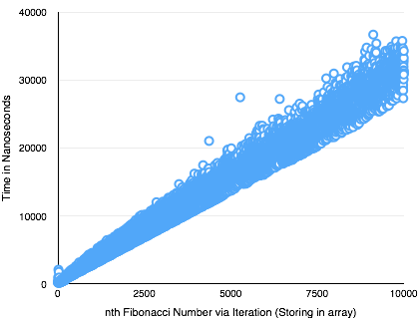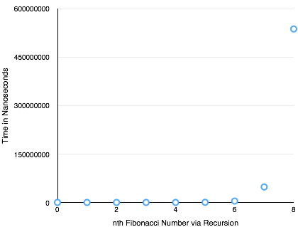ta:

